TEXAS INSTRUMENTS: DATABASE CLEANUP

Team Members:
Aidan Johnson
Sterling Gayle
Nestor Reyes
Anil Lingala
Marco Ghercioiu
Abstract: In order to optimize the efficiency of the TI databases, unnecessary and extraneous information will be removed, which will result in quicker processing times for important queries and lower costs to maintain the systems.

TABLE OF CONTENTS
- EXECUTIVE SUMMARY ……3
- INTRODUCTION……4
- RESOURCES……4
- KEY ROLES……4
- COMMUNICATION PLAN……5
- RISK ANALYSIS……6
- COSTS……6
- TIMETABLE……6
- EVALUATION……7
- CONTACT INFORMATION……7
- SOURCES……8
- APPENDIX……8
- NAMES AND SIGNATURES ……9

- EXECUTIVE SUMMARY
Texas Instruments Incorporated is an American technology company headquartered in Dallas, Texas, that designs and manufactures semiconductors and various integrated circuits, which it sells to electronics designers and manufacturers globally.
The Texas Instruments database cleanup process is a project designed to automate the cleanup of the growing unused objects within company databases and lessen storage footprint. Texas Instruments currently uses Oracle’s database service. The database is accessible through the Oracle sql developer software, in which the project team will deploy the procedures, functions, and queries to complete the cleanup process. The primary objectives defined by TI are: audit log capability, VCS sync, email notification, and a configuration table.
Audit Log Capability
The audit log assists in the monitoring of changes to the database. This involves tracking user signatures and timestamps for actions.
VCS Sync
The version control sync works jointly with the database cleanup process to store a copy of any potentially deleted objects in the GIT repo.
Email Notification
Email relevant developers to approve any deletion of an object.
Configuration Table
Configure objects that should not be deleted.
The database cleanup process begins by identifying candidate objects that are unused. Configuration tables are employed to control deletion time and approval for each object. The relevant developer/s is notified when a potential deletion is identified and may approve or decline deletion. Once an object is ready for deletion, it is added to the GIT version control sync and then removed from the database.
Texas instruments does not currently use a database cleanup process. Any deletion of objects in the database must be done manually. This project is beneficial to Texas Instruments because the manual deletion of unused objects will be automated, increasing the speed and efficiency of deletion. Texas Instruments wants to speed up the cleanup process because database storage size and query speed will decrease.

- INTRODUCTION
The primary aim of this project is to develop an automated process of TI Database cleanup.
The main objectives (as mentioned above) include:
- Making sure that we work accordingly with VCS Sync to ensure that copies of data that are being deleted will get stored there.
- Having an audit log capability.
- Maintain a configuration table that contains details regarding the info to not be deleted.
- Sending email notifications and reminders to the relevant developers.
- Having the same approval process.
Our work is divided into phases. Based on our assigned roles, we will follow the objectives to ensure that the clean up process happens smoothly. We intend to implement the clean up process such that the data is organized and the process is efficient.
- RESOURCES
All the team members are considered to be resources. Our corporate mentor, Melissa Bolcar, is also a valuable resource, as well as her colleague Ben O’Brien who has graciously lended us his assistance. In terms of hardware, we are using our own personal computers, and connecting to the TI network through GlobalProtect VPN. The software used to communicate with the database is Oracle SQL Developer.
- KEY ROLES
Audit Log and Initialize - Marco Ghercioiu
Audit Summary - Anil Lingala
Potential Candidates - Sterling Gayle, Nestor Reyes
Email Contact - Aidan Johnson
- COMMUNICATION PLAN:
The weekly meetings are held with Melissa and Ben from Texas Instruments. Every meeting, we will instead discuss what has been accomplished since the last meeting and the general progress of our project.

Additionally, team members use Discord to communicate with each other outside of the sponsor meetings.

We work on different softwares including google products such as Docs, Sheets, Slides and other management tools such as Trello.

Excel sheets will be used to track milestones and dates, and Trello is used for work distribution. We would also use other technical communication tools based on our requirements.

- RISK ANALYSIS
 | Low Probability | Medium Probability | High Probability
High Impact | - Improper usage of database according to company rules  - Incorrect attributes for database objects | - Unable to connect remotely to database  - Poor communication between company and team | - Unexpected deletion of database objects
Medium Impact | - Failure to be present at weekly meeting  - Team member out sick for extended time | - Project specification changes  - Slight errors in software  - Software does not meet company expectations | - Poor understanding of project specification  - Software design not completed in time  - Unexpected issues with technology used
Low Impact | - Software unavailable to group members remotely  - Failure of services used outside of company and team control | - Incorrect version of software used to communicate with database  - Incorrect formatting of database objects set for deletion | - Team member contribution limited due to busy school week  - Difference in time-zone between team members/ company employees

B. CONTINGENCY PLAN
High Impact
Immediately contact project leaders including company and school sponsors. Document all relevant communication regarding risk. Reconsider project timeline and objectives.
Medium Impact
Update team and project leaders in a timely manner. Ask questions to clarify any misunderstandings. Update any errors in software or project documents.
Low Impact
Assess problems individually and communicate with the project team if stuck. Schedule according to team availability. Follow pre-defined guidelines for formatting.

- COSTS
We have not bought any software or hardware and have not touched the $1000.

- TIMETABLE
Phase I: due 03/18/22: Have a functioning understanding of the database and a plan for how the clean-up process will be implemented.
Phase II: due 04/01/22 : Have a “hub” for the clean-up process.
Phase III: due 04/29/22: Have a fully functioning clean-up process.

- EVALUATION
  - Progress Tracking Plan:
We can keep an excel sheet to keep up with milestones and dates (will contain the following table).
We will divide our assigned project into different, equal periods to ensure progress. Each period represents the months from February to May.
We will meet at least once a week for the sponsor meetings. (Friday 9am - 10 or 11am). The meetings with the sponsors will be on Webex (online).
Outside of sponsor meetings, our group will make sure to meet at least 1-2 hours or more to keep track of our updates on the project. Our group meetings currently are in Discord and will be expanded to other tools if needed.
Regular updates are monitored using Trello
  - Performance Metrics – The following are the performance goals used to determine the functionality and usability of the project:
      - Lightweight enough to be able to run daily.
      - At the very least, O(n) efficiency.
      - Limited in number of requests.
      - Can only be run manually by developers.

Important metrics to collect from the project:
Scan time - Time to scan all viable data conditions.
Action Time - Time to perform data erasures.
Total Run Time - Scan time + action.
Number of requests - Number of items to delete.
Percentage of requests fulfilled - Requests able to be successfully removed.
Locked Datasets - Datasets not allowed to be removed.

- CONTACT INFORMATION (Your contact information and short bios are good enough)
Sterling Gayle: (214) 543-2453 - sterlingkgayle@gmail.com
Computer Science senior looking to specialize in back-end.
Aidan Johnson : (440) 725-1590 - firelightaidan@gmail.com
Senior majoring in Computer Science,with experience in customer support and communication roles
Anil Lingala : (469)403-5362 - akl180001@utdallas.edu
Senior at UTD pursuing Computer Science with interest and experience in back-end developing.
Marco Ghercioiu: (512)586-3770 - marco.ghercioiu@gmail.com
Computer Science senior with experience in full stack development.
Nestor Reyes: (214)672-3574 - nestorreyesdan@gmail.com
Senior in Computer Science with general programming knowledge as well as sql.

- SOURCES (REFERENCES, BIBLIOGRAPHY)
Bolcar, Melissa. (2022, Jan. 24) Database Cleanup Process [Powerpoint presentation]. Texas Instruments, (Virtual) Dallas, TX, United States.

XII. APPENDIX (references, and all extra documents that you may need to consult)
Joshi, K. [BBarters]. (2014, November 5). Learning PL/SQL programming [Video]. YouTube. https://www.youtube.com/watch?v=xofpqdU3cD4&t=894s

XIII. NAMES AND SIGNATURES
_______________________  Aidan Johnson 02/24/2022  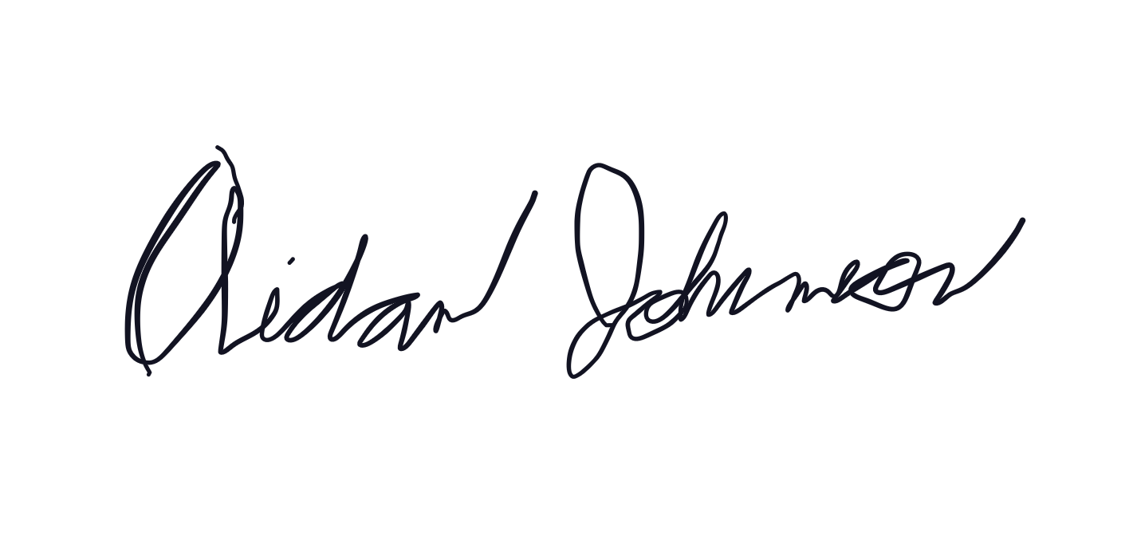 | _______________________  Sterling Gayle 02/24/2022  
_______________________  Nestor Reyes 02/24/2022  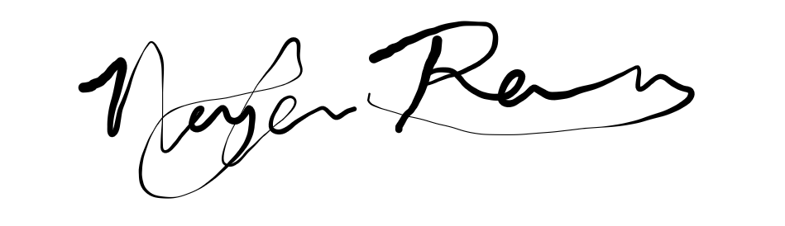 | _______________________  Anil Lingala 02/24/2022
_______________________  Marco Ghercioiu 02/24/2022   | _______________________  Wei Yang  
_______________________  Melissa Bolcar | _______________________

